CIS 435: Web Technology

Project #3: SportsPro Tech Support



November 25, 2018

Fall 2018

Table of Contents

**Team Members** **3**

**Team Member Contributions** **3**

**Screenshots** **4**

6.1 - Manage Products 4

The Product List Page 4

The Add Product Page 5

6.2 - Manage Technicians 6

The Technician List Page 6

The Add Technician Page 6

6.3 - Manage Customers 7

The Select Customer Page 7

The View/Update Customer Page 8

6.4 - Register Product 9

The Customer Login Page 9

The Register Product Page (view 1) 9

The Register Product Page (view 2) 10

6.5 - Create Incident 10

The Get Customer Page 10

The Create Incident Page (view 1) 11

The Create Incident Page (view 2) 11

# Team Members

Dujon Brown

Omari Chatman

Srinivas Simhan

# Team Member Contributions

Dujon Brown - 6.1,6.2

Omari Chatman - 6.3, 6.4, 6.5

Srinivas Simhan - 6.5, Documentation

# Screenshots

## 6.1 - Manage Products

### The Product List Page

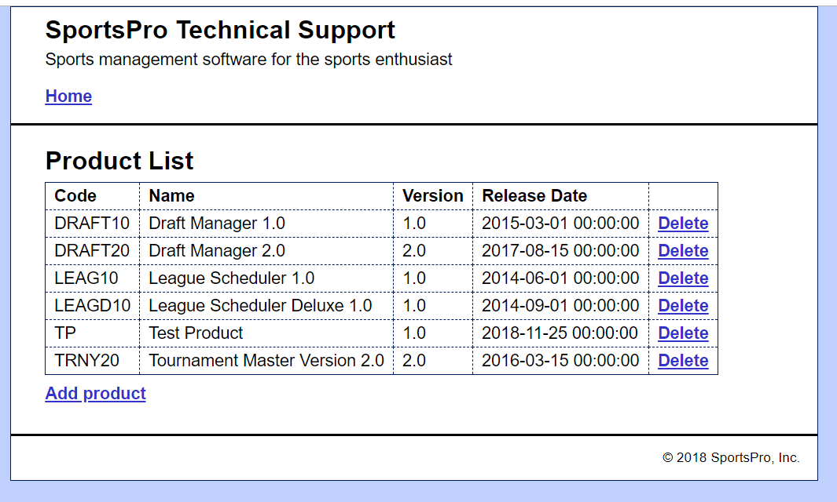

### The Add Product Page

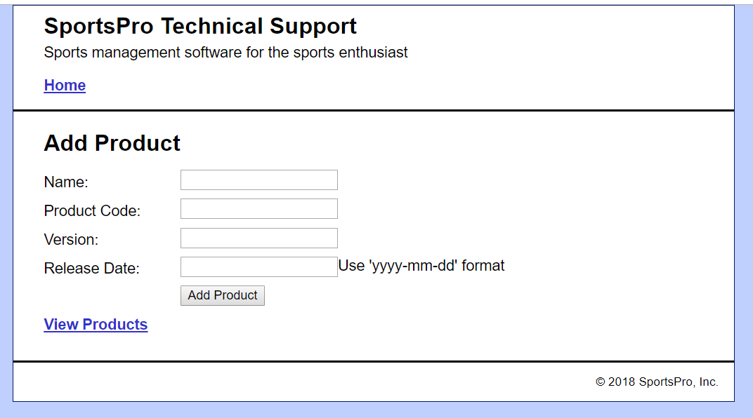

## 

## 6.2 - Manage Technicians

### The Technician List Page

## 

### The Add Technician Page

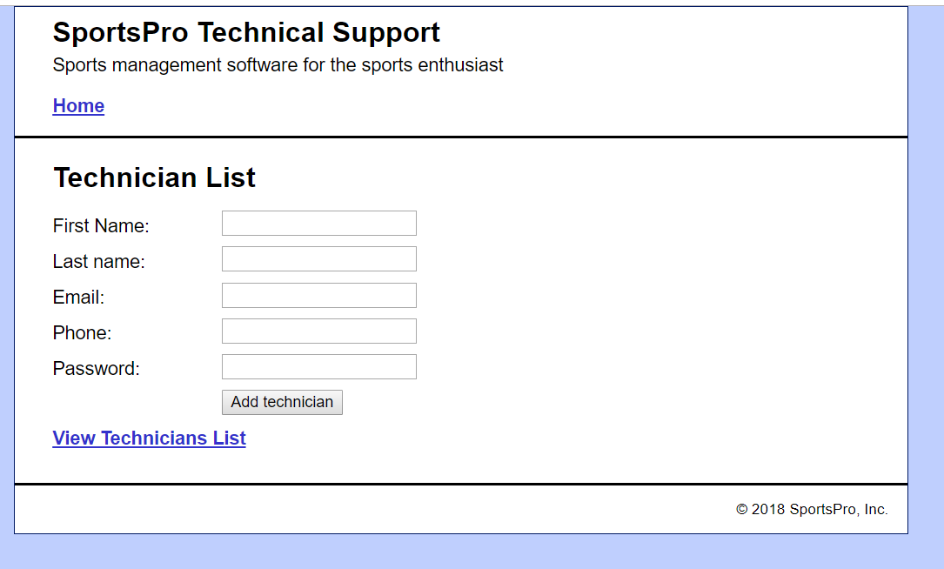

## 6.3 - Manage Customers

### The Select Customer Page

## 

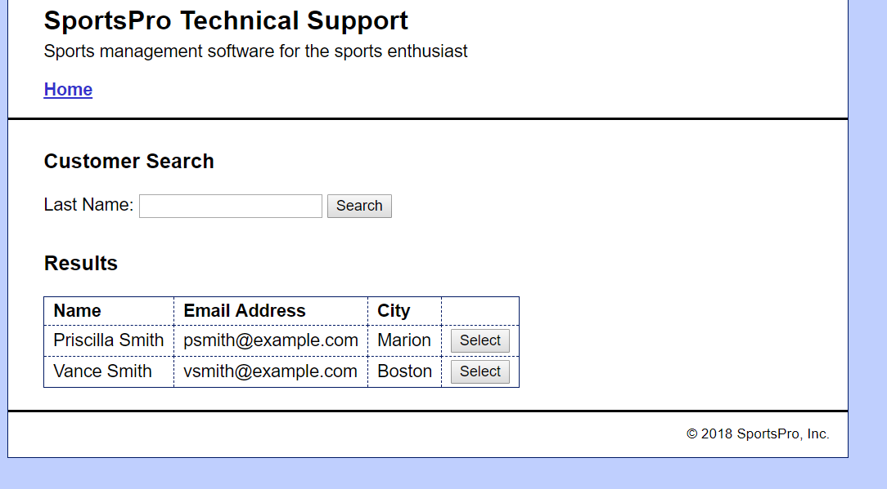

### The View/Update Customer Page

## 

## 6.4 - Register Product

### The Customer Login Page

## 

### The Register Product Page (view 1)

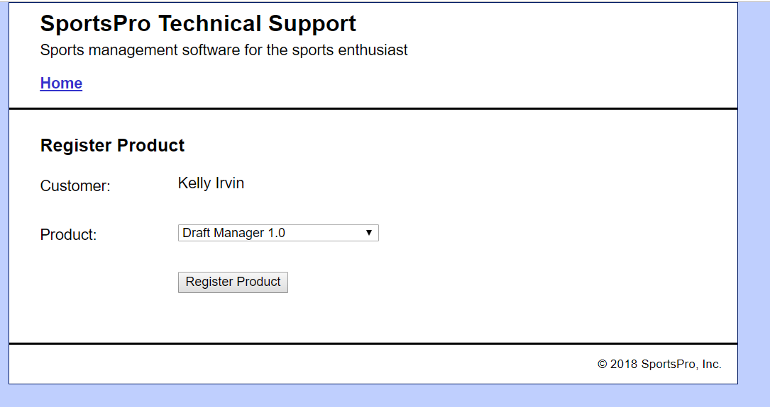

### The Register Product Page (view 2)

## 6.5 - Create Incident

### The Get Customer Page

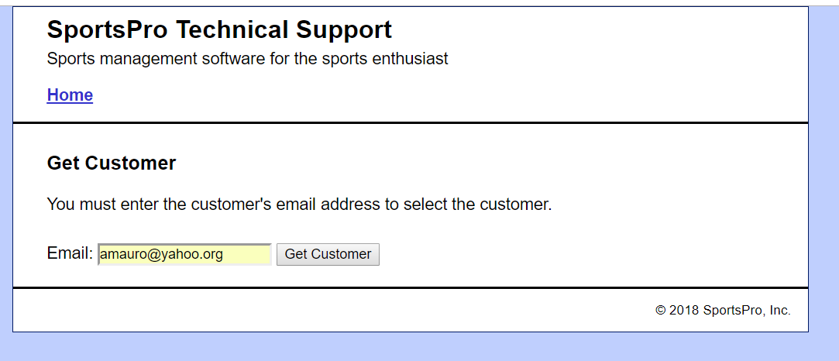

### The Create Incident Page (view 1)

### The Create Incident Page (view 2)

